**Windows 10 UWP – Hands on Lab**

**Lab 5:**

**Note**: The demo app created for this lab uses Visual Studio 2015 with the latest Windows Tools SDK version 10240. To help with our coding efforts with the boiler code and page navigation we use a UWP app extension called Template 10.

1. Open the \ViewModels\DetailPageViewModel.cs file and add the following lines of code to line 87.

public void ShareBBQRecipe()

     {

         if (!String.IsNullOrEmpty(recipe.Id))

         {

             DataTransferManager.ShowShareUI();

         }

     }

     private async void DataTransferManager_DataRequested(DataTransferManager sender, DataRequestedEventArgs args)

     {

         DataRequestDeferral deferral = args.Request.GetDeferral();

         args.Request.Data.Properties.Title = recipe.Name;

         args.Request.Data.SetText(recipe.ShortDesc);

         StorageFile storageFile = await Windows.Storage.StorageFile.GetFileFromApplicationUriAsync(recipe.ImageUri);

         args.Request.Data.SetBitmap(RandomAccessStreamReference.CreateFromFile(storageFile));

         deferral.Complete();

     }

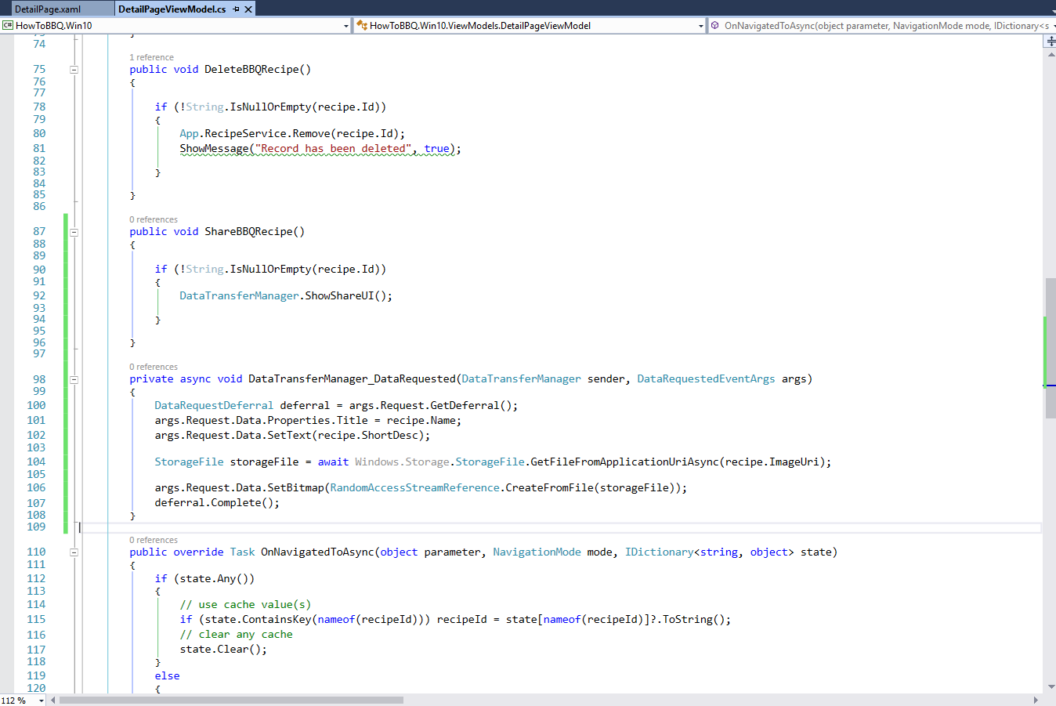

1. Make sure you have the following using statements within DetailPageViewModel.cs.

using Windows.ApplicationModel.DataTransfer;

using Windows.Storage;

using Windows.Storage.Streams;

1. Open the \Views\DetailPage.xaml file and make sure the following lines of Xaml code are located on line 127. This button will be added to the StackPanel labelled “ButtonPanel”.

<Button Margin="10" x:Name="ButtonShare" Content="Share" FontSize="32"  Click="{x:Bind ViewModel.ShareBBQRecipe}">

                                <Button.Background>

                                    <LinearGradientBrush EndPoint="0.5,1" StartPoint="0.5,0">

                                        <GradientStop Color="#FFC681F2" Offset="0.171"/>

                                        <GradientStop Color="#FF0A0A0A"/>

                                        <GradientStop Color="#FF0A0A0A" Offset="0.98"/>

                                        <GradientStop Color="#FFC681F2" Offset="0.949"/>

                                    </LinearGradientBrush>

                                </Button.Background>

                            </Button>

